User manual



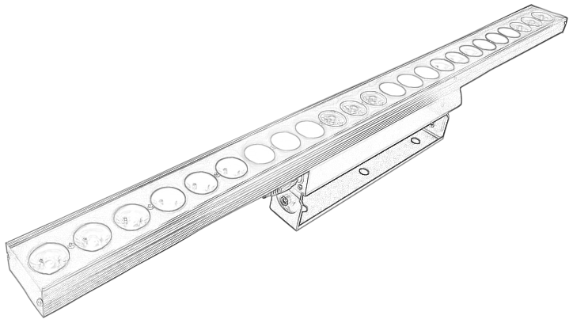
LED BAR 24x8 PL
Please read the instructions carefully before use

TABLE OF CONTENTS
- Safety Instructions……………………………………………………………………………3-4
- Technical Specifications…………………………………………………………………………4
- Control Menu ………………………………………………………………………………………5
- DMX Channels ……………………………………………………………………………………6
- Trouble Shooting………………………………………………………………………………….7
- Fixture Cleaning………………………………………………………… ………………………7

STATEMENT
The product has well capability and intact packing when leave factory. All of the user should comply with warning item and manual, any misuse cause of the damages are not included in our guarantee, and also can not be responsible for any malfunction & problem owing to ignore the manual.

1.Safety Instructions
Please keep this User Guide for future consultation. If you sell the unit to another user, be sure that they also receive this instruction booklet.
•Unpack and check carefully there is no transportation damage before using the unit.
•Before operating, ensure that the voltage and frequency of power supply match the power requirements of the unit.
•It’s important to ground the yellow/green conductor to earth in order to avoid electric shock.
•The unit is for indoor use only. Use only in a dry location.
•The unit must be installed in a location with adequate ventilation, at least 50cm from adjacent surfaces. Be sure that no ventilation slots are blocked.
•Disconnect main power before replacement or servicing.
•Make sure there are no flammable materials close to the unit while operating as it is fire hazard.
•Use safety cable when fixes this unit. DO NOT handle the unit by taking its head only, but always by taking its base.
•Maximum ambient temperature is Ta: 40℃. DO NOT operate it where the temperature is higher than this Unit surface temperature may reach up to 85℃. DO NOT touch the housing bare-hand during its operation. Turn off the power and allow about 15 minutes for the unit to cool down before replacing or serving.
•the event of serious operating problem, stop using the unit immediately.Never try to repair the unit by yourself. Repairs carried out by unskilled people can lead to damage or malfunction. Please contact the nearest authorized technical assistance center. Always use the same type spare parts.
•DO NOT touch any wire during operation as high voltage might be causing electric shock.
Warning:
•To prevent or reduce the risk of electrical shock or fire, do not expose the unit to rain or moisture.
•The housing, the lenses, or the ultraviolet filter must be replaced if they are visibly damaged.
Caution:
•There are no user serviceable parts inside the unit. DO NOT open the housing or attempt any repairs yourself. In the unlikely event your unit may require service, please contact your nearest dealer.
Installation:
•The unit should be mounted via its screw holes on the bracket. Always ensure that the unit is firmly fixed to avoid vibration and slipping while operating. And make sure that the structure to which you are attaching the unit is secure and is able to support a weight of 10 times of the unit’s weight. Also always use a safety cable that can hold 12 times of the weight of the unit when installing the fixture.
•The equipment must be fixed by professionals. And it must be fixed at a place where is out of the touch of people.

2.Technical Specifications
Light source: 24 x 8W RGBW 4in1 led
Input Voltage : AC100-240V 50-60Hz
Beam angle:25degree
Control Model: DMX512/Auto Run/Slave-Master/Sound
DMX Channel: 12/32 ch
IP Rate: IP20
Dimensions : L1000* W65* H140 mm
NW:3 KGS

3.Control Menu
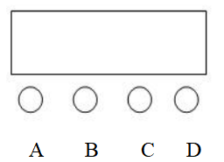

No | Show | Function Instruction
1 | d001 | DMX Address（001—512）  32 Channels mode
2 | A001 | DMX Address（001—512）  12 Channels mode
3 | R255 | Red Dimming, From dark to light
4 | G255 | Green Dimming, From dark to light
5 | B255 | Blue Dimming, From dark to light
6 | U255 | White Dimming, From dark to light
7 | FH01 | (01-08) 8Color output
8 | CL01 | (01-50) 50 effects, speed from slow to fast
9 | SP99 | (01-99) Function speed, from slow to fast
10 | DE99 | (01-99) Gradient speed from slow to fast
11 | CC99 | (01-99) Jump speed from slow to fast
12 | SU09 | (01-09) Sound control

4.DMX Channels
12 Channels Mode:
Channel | DMX Value |  | Function
CH1 | 000-255 | Dimmer | RGBW Total Dimming, From dark to light
CH2 | 000-255 | Red | Red dimming,From dark to light
CH3 | 000-255 | Green | Green dimming,From dark to light
 | 000-255 | Blue | Blue dimming,From dark to light
CH5 | 000-255 | White | White dimming,From dark to light
CH6 | 000-255 | Strobe | RGBW Strobe,SPEED FROM SLOW TO FAST
CH7 | 000-009 | Feature selection | Dmx Dimming
CH7 | 010-255 | Feature selection | effect
CH8 | 000-255 | Feature speed | From slow to fast
CH9 | 000-255 | Red1 | Red background Dimming, From dark to light
CH10 | 000-255 | Green1 | Green background Dimming, From dark to light
CH11 | 000-255 | Blue1 | Blue background Dimming, From dark to light
CH12 | 000-255 | White1 | White background Dimming, From dark to light

32 Channels Mode:
Channel | DMX Value |  | Function
CH1 | 000-255 | R1 | Red 1 Dimming, From dark to light
CH2 | 000-255 | G1 | Green 1 Dimming, From dark to light
CH3 | 000-255 | B1 | Blue 1 Dimming, From dark to light
CH4 | 000-255 | W1 | White 1 Dimming, From dark to light
CH5 | 000-255 | R2 | Red 2 Dimming, From dark to light
CH6 | 000-255 | G2 | Green 2 Dimming, From dark to light
CH7 | 000-255 | B2 | Blue 2 Dimming, From dark to light
CH8 | 000-255 | W2 | White 2 Dimming, From dark to light
CH9 | 000-255 | R3 | Red 3 Dimming, From dark to light
CH10 | 000-255 | G3 | Green 3 Dimming, From dark to light
CH11 | 000-255 | B3 | Blue 3 Dimming, From dark to light
CH12 | 000-255 | W3 | White 3 Dimming, From dark to light
CH13 | 000-255 | R4 | Red 4 Dimming, From dark to light
CH14 | 000-255 | G4 | Green 4 Dimming, From dark to light
CH15 | 000-255 | B4 | Blue 4 Dimming, From dark to light
CH16 | 000-255 | W4 | White 4 Dimming, From dark to light
CH17 | 000-255 | R5 | Red 5 Dimming, From dark to light
CH18 | 000-255 | G5 | Green 5 Dimming, From dark to light
CH19 | 000-255 | B5 | Blue 5 Dimming, From dark to light
CH20 | 000-255 | W5 | White 5 Dimming, From dark to light
CH21 | 000-255 | R6 | Red 6 Dimming, From dark to light
CH22 | 000-255 | G6 | Green 6 Dimming, From dark to light
CH23 | 000-255 | B6 | Blue 6 Dimming, From dark to light
CH24 | 000-255 | W6 | White 6 Dimming, From dark to light
CH25 | 000-255 | R7 | Red 7 Dimming, From dark to light
CH26 | 000-255 | G7 | Green 7 Dimming, From dark to light
CH27 | 000-255 | B7 | Blue 7 Dimming, From dark to light
CH28 | 000-255 | W7 | White 7 Dimming, From dark to light
CH29 | 000-255 | R8 | Red 8 Dimming, From dark to light
CH30 | 000-255 | G8 | Green 8 Dimming, From dark to light
CH31 | 000-255 | B8 | Blue 8 Dimming, From dark to light
CH32 | 000-255 | W8 | White 8 Dimming, From dark to light

5.Trouble Shooting
Following are a few common problems that may occur during operation. Here are some suggestions for easy troubleshooting:

A. The unit does not work, no light and the fan does not work
1. Check the connection of power and main fuse.
2. Measure the mains voltage on the main connector.
3. Check the power on LED.

B. Not responding to DMX controller
1. DMX LED should be on. If not, check DMX connectors, cables to see if link properly.
2. If the DMX LED is on and no response to the channel, check the address settings and DMX polarity.
3. If you have intermittent DMX signal problems, check the pins on connectors or on
PCB of the unit or the previous one.
4. Try to use another DMX controller.
5. Check if the DMX cables run near or run alongside to high voltage cables that may cause damage or interference to DMX interface circuit.
C. One of the channels is not working well
1. The stepper motor might be damaged or the cable connected to the PCB is broken.
2. The motor’s drive IC on the PCB might be out of condition

6.Fixture Cleaning
The cleaning of internal and external optical lenses and/or mirrors must be carried out periodically to optimize light output. Cleaning frequency depends on the environment in which the fixture operates: damp, smoky or particularly dirty surrounding can cause greater accumulation of dirt on the unit’s optics.
• Clean with soft cloth using normal glass cleaning fluid.
• Always dry the parts carefully.
• Clean the external optics at least every 20 days. Clean the internal optics at least every 30/60 days.

